Ages 3-13   
REGISTRATION DEADLINE: August 23, 2024

Name: __________________________________ Age: ____________ DOB: ___________________

Grade: __________ School: ______________   
Sex: __________ Years in Program: ___________

Parent/Guardian Name: _______________________________________

Address: ________________________________

City: ___________________________________

State: _______________ Zip: ________________

Phone: _________________________________

Email: ___________________________________

Please Circle Shirt Size:

Youth: S M L Adult: S M L XL

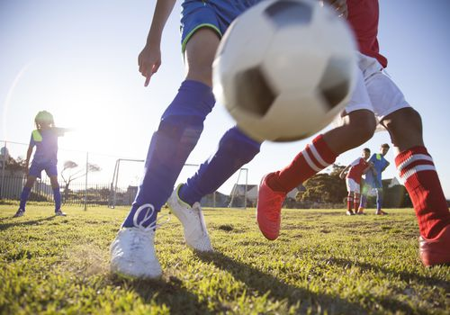

Practices begin in September.

Games will be on Weeknights and Sunday Afternoons. Space is limited.   
After registration deadline please call for availability.

SHIRTS WILL BE PROVIDED. SHIN GUARDS REQUIRED TO PLAY.   
*SOCCER CLEATS RECOMMENDED BUT NOT REQUIRIED TO PARTICIPATE.*  
(Returned Check Fee: $20.00)  
*No Refund of Program Fees after First Practice*.   
*All refunds are subject to a $2 fee*   
**There will be no switching teams after being assigned**

**Please Circle Age as of August 31, 2024**Age: 3 or 4 Age: 5 or 6 Age: 7 or 8   
 Age: 9 or 10 Age: 11, 12 or 13

Please Help if You Can!

Contact me, I would like to:

Coach: ________ Assist. Coach: ________

Sponsor Team (fee $200.00) ________

***\*To ensure player safety a background check will be done on all coaches and assistants.***



Player Fees:

**EARLY BIRD SPECIAL!   
REGISTER BY AUG 16TH  
 AND SAVE $10!**

Ages 3-4 = $60.00 (EB $50)  
Ages 5-6 = $60.00 (EB $50)  
Ages 7-8 = $60.00 (EB $50)  
Ages 9-10 = $65.00 (EB $55)  
Ages 11-13 = $65.00 (EB $55)  
*($10 discount for each additional child)*

**LIABILITY RELEASE:** By signing below I, as a participant or legal guardian representing a minor participant, agree to release the Brown County Parks & Rec. (“BCPR”) Dept, its officers, employees, and volunteers from all liability for accidents, injuries,illnesses (including but not limited to unknown risks/exposure to COVID-19) loss of and/or damage to my/our person or property that may arise out of my/our participation in or my/our presence at the above activity(s). I/We are aware that there are certain risks or possible dangers in participating in this activity. I have entered into this agreement of my own free will.

**MEDICAL RELEASE:** In case of illness or accident, permission is granted to take the above person to the hospital or doctor’s office for medical attention.

**Code of Ethics Release:** As a participant or spectator**,** I (we) agree to abide by, follow and comply with the rules, policies, and expectations of the BCPR program and will conduct myself (ourselves) in a courteous and respectful manner by exhibiting good sportsmanship and being a positive role model for youth. I (we) also understand that failing to do so will constitute grounds for sanctions and/or dismissal from the program.

**Picture Release:**  I, as a participant or legal guardian representing a minor participant, agree to allow BCPR to use photographs taken at events for promotional purposes.

**Emergency Contact** *(if parent/guardian cannot be reached):* __________________________________________

**Emergency Contact Phone**: ___________________________________________________

**Physical Limitations** (allergies, hearing, sight, etc.):

___________________________________________________________________________________

**Parent/Guardian Signature: _____________________________________________________**

Please read, complete, sign form, and return with payment to:

Brown County Parks & Recreation  
902 Deer Run Lane Ste B  
Nashville, IN 47448  
Phone: 812-988-5522   
or register on-line @ bcparksrec.com